layers = [
imageInputLayer([32 32 3],'Name','input')
convolution2dLayer(5,6,'Name','conv_1')
batchNormalizationLayer('Name','BN_1')
reluLayer('Name','relu_1')
maxPooling2dLayer(2,'Stride',2,'Name','pool_1')
convolution2dLayer(5,16,'Name','conv_2')
batchNormalizationLayer('Name','BN_2')
reluLayer('Name','relu_2')
maxPooling2dLayer(2,'Stride',2,'Name','pool_2')
fullyConnectedLayer(400,'Name','fc_3')
fullyConnectedLayer(10,'Name','fc_4')
softmaxLayer('Name','softmax')
classificationLayer('Name','classOutput')];
layer1=layerGraph(layers);
plot(layer1)
analyzeNetwork(layer1)
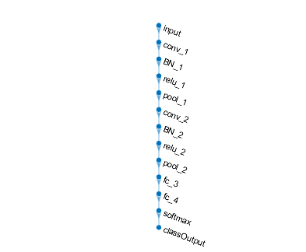
Published with MATLAB® R2021a

